Exponential Functions

John Wensink

MTH122-1

Colorado State University-Global Campus

Professor Mirella Negoita

August 24, 2020

Exponential Functions

For the previous seven months, I have studied 200g of radioactive material and observed its mass diminish due to natural radioactive decay. I have observed the following data, and am interested in studying the exponential function that describes the decay of this substance.

|  |  |
| --- | --- |
| **Month** | **Weight** |
| 0 | 200 |
| 1 | 176.6 |
| 2 | 151.8 |
| 3 | 138.8 |
| 4 | 118.2 |
| 5 | 103.6 |
| 6 | 91 |

**Scatter Plot**

Using a graphing utility, draw a scatter diagram with month and weight as your variables:

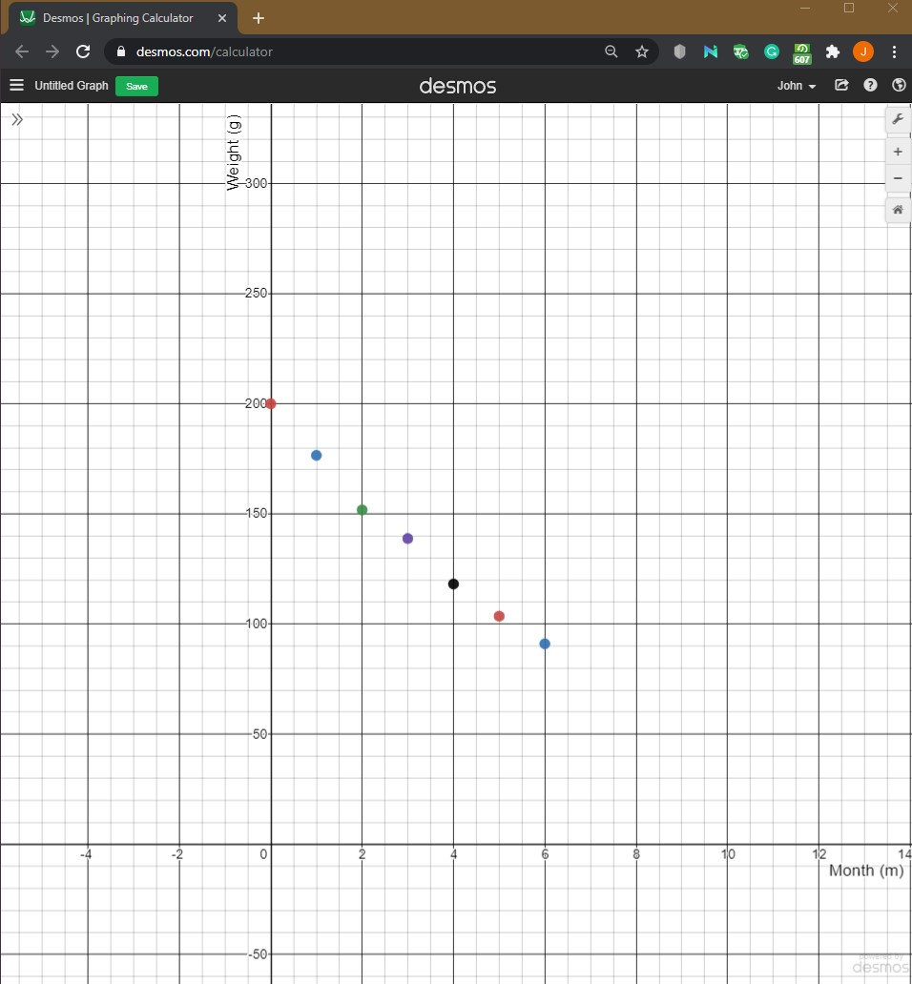

**Build an Exponential Model**

Using a graphing utility build an exponential model from the data:

I don’t think I understand the question

**Express Weight as a Function of Months**

Let’s say that our exponential function is y=abx. We can say that a is the original amount of material which we start with, and b can be our exponential decay rate of which the average loss per month (0.883+0.86+0.914+0.852+0.876+0.878)/(6) = 0.877g/m. Therefore a=200g,b=0.877g; y=200(.877)x where y is the weight of the substance at x number of months.

**Graph the exponential Function From Scatterplot**

Adding the equation as a function above our scatterplot yields a near-perfect regression line:

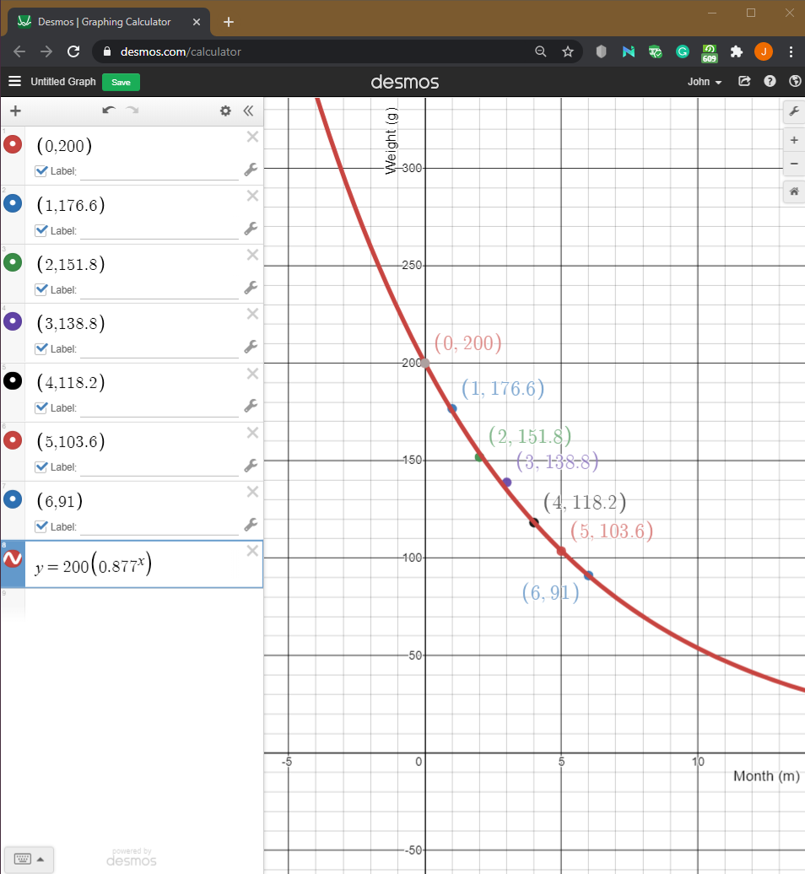

**Interpret the Parameters of this Function**

This exponential function includes the x and y parameters, namely, x represents the number of months from when we started measuring the substance’s radioactive decay, and y represents the weight of the substance after that many months of decay have taken place

**Determine the Half-Life of the Substance**

In order to determine the half-life, we want to find out in terms of months (x) when the weight of the substance (y) = 100:

100=200(0.877)x

(100)/(200)= (0.877)x

0.500=(0.877)x

ln(0.5)=x ln(0.877)

~0.69 =~ x -(0.13)

x = 0.69/0.13= 5.307

The half life of this substance is 5.3 months, rounded to the nearest month yields an approximate 5 month half life.

**How Much Will be Left After 30 Months?**

After 30 months, we can use the exponential function the same as above:

y=200g(0.877)30

y=~200g(0.019)

y=~3.899g

y=~3.9g

**When Will You have 40g of this Material?**

In order to determine when we will have 40g of this material all we have to do is solve the equation where y=40:

40=200g(0.877)x

40/200 = (0.877)x

0.2=(0.877)x

ln (0.2) = x ln(0.877)

-1.609 = ~x-(0.131)

x= 1.609/0.131

x=12.282months

x~12.3 months

**Conclusion**

Once we get a working exponential model to describe the rate of decay of our radioactive material, it is easy to manipulate the function to isolate the variable of our choice whether it be time or weight. As a logarithmic function is the inverse of our exponential function, it is useful to use natural log (ln) to help us solve for variables which are exponents. This substance seems to be extremely radioactive, and as such must be handled with care.